Customer Scout INC

Technical Test

Name: Jass Khinda

1. Write a HTML & CSS codes with Bootstrap and create a similar page as shown below.

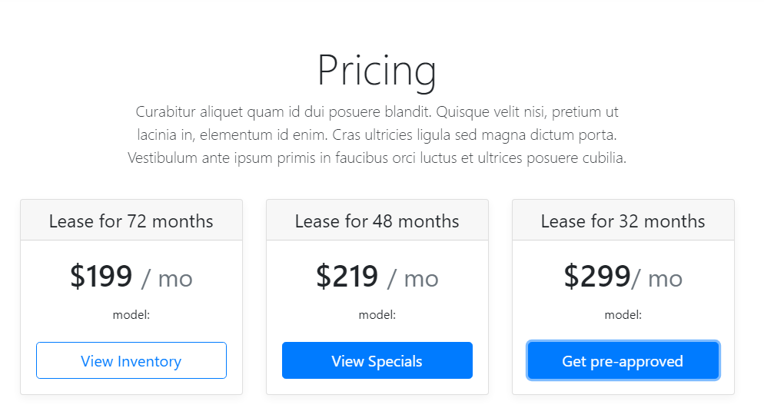

Answer = Please check the attached “Bootstrap and HTML” folder for my responsive HTML/CSS solution using Bootstrap.

1. Write a HTML only using **in-line CSS without Bootstrap** and create similar page as above.

Answer = Please check the attached “HTML with Only Inline CSS” folder for the same page recreated using inline CSS.

1. Create a Homepage banner (check the banner size from the live site) for this page <https://www.puentehillscdjr.com/srt-demon-170/>

Please check the attached “banner.html” file. This file contains the homepage banner for the SRT Demon page (<https://www.puentehillscdjr.com/srt-demon-170/>) along with the appropriate sizing and background image as specified.

1. Run the site health check (broken links) on the following 2 sites – you can use any tool. Explain how fix them If there are any issues.

<https://www.tegelerchevrolet.com>

<https://www.pueblotoyota.com>

Please check the attached “Sites Health Report.docx” file for a detailed broken link analysis and my recommendations on how to fix the issues for both tegelerchevrolet.com and pueblotoyota.com.